W-16

12 PHYSICS ATAR

TEST 7 - LIGHT AND ATOMIC PHYSICS

NAME: MARK: 

1. The colour of a star depends on its surface temperature. Which of these colours indicates the highest temperature? [1 mark]

(a) Blue

(b) Green

(c) Yellow

(d) White

2. White light is shone through a glass bottle containing a solution of nickel chloride. The colour of the light that emerges out of the other side is a green-blue mixture. If this light is dispersed through a prism the type of spectrum that results is classified as: [1 mark]

(a) band emission.

(b) band absorption.

(c) line emission.

(d) line absorption.

3. Which of the following can occur when a photon strikes an atom? [1 mark]

(a) It can lose all of its energy or it can lose part of its energy.

(b) It can lose part of its energy or it can lose none of its energy.

(c) It can lose all of its energy or it can lose none of its energy.

(d) It can lose all of its energy, it can lose part of its energy or it can lose none of its energy.

4. What is the energy of a photon of green light with a wavelength of 535 nm?

[1 mark]

(a) 3.72 x 10‐19 J

(b) 3.54 x 10‐40 J

(c) 1.06 x 10‐22 J

(d) 3.54 x 10‐31 J

5. Which of the following transitions in a hydrogen atom will emit a photon with the longest wavelength of light? [1 mark]

(a) n = 3 to n = 4

(b) n = 5 to n = 4

(c) n = 2 to n = 1

(d) n = 3 to n = 2

6. Covalent bonds in a molecule absorb radiation in the infra-red (IR) region and vibrate at certain frequencies. The HCl bond has a frequency of 8.652 x 1013 Hz. What wavelength corresponds to this frequency? [1 mark]

(a) 3.467 nm

(b) 3467 nm

(c) 5733 nm

(d) 3.733 nm

7. An office worker wants to heat a cup of coffee. She uses a 750 W microwave oven, with a frequency of 2.5 GHz, to heat 600 mL of water in a jug. The water heats up but the jug remains cool during this time.

(a) What is the wavelength of the microwave radiation? [2 marks]

(b) How much energy (in ***J*** and ***eV***) does one microwave photon possess? [2 marks]

(c) Given that it took 2.75 minutes to heat the water to an acceptable drinking temperature, how many photons were used to heat the water? [4 marks]

8. The element Mercury (Hg) has a work function of 4.50 eV when exposed to light.

(a) Determine the threshold frequency for Mercury. [4 marks]

(b) When 400 nm light is incident on the sample of Mercury, photoelectrons are emitted. Calculate the maximum speed of the photoelectrons that are emitted. [5 marks]

(c) The photoelectric effect marked a major departure from the theories of light established in classical physics. Explain what is meant by the classical nature of light. [1 mark]

(d) How can the classical nature of light be shown to be true? [1 mark]

(e) How does the photoelectric effect deviate from that described in part (d)? [1 mark]

9. The following diagrams show a 30 kV X-ray tube and a graph of the X-ray energy range produced.

|  |  |
| --- | --- |
|  |  |

(a) Why is a range of X-ray energies produced? [2 marks]

(b) How are the peak energy X-rays produced? [2 marks]

(c) What is the wavelength of the most energetic X-ray produced? [3 marks]

(d) How fast are the electrons travelling when they strike the metal target? [3 marks]

(e) The tube voltage can be varied. On the graph below draw:

(i) the graph showing the range and intensity of the X-rays produced if a higher accelerating voltage (40 kV) is used. [2 marks]

(ii) The Kα and Kβ peaks for this sample. [1 mark]

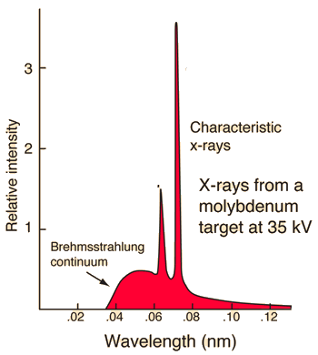

10. NOVA 93.7 FM is a popular Perth radio station. Calculate the energy of a typical radio wave photon emitted during a daily radio show. Give your answer in ***electron volts***. [3 marks]

11. The graph below shows how the maximum kinetic energy of the electrons varies with the frequency of the light shining on the metal surface.

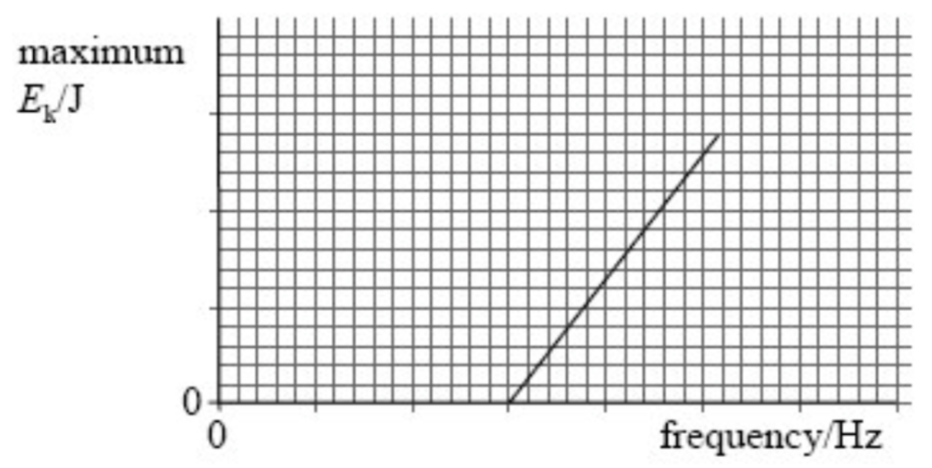

(a) ***On the graph*** mark the threshold frequency and label it fo. [1 mark]

(b) ***On the graph*** draw the graph for a metal that has a greater work function than the sample shown. [2 marks]

12. This figure shows the energy level diagram of a hydrogen atom.

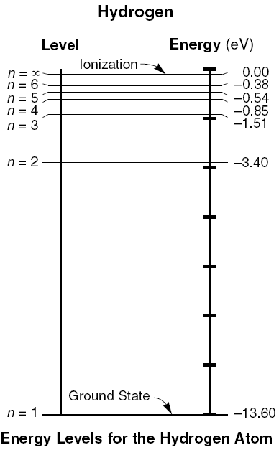

(a) Calculate the frequency of the photon emitted when an electron transitions from n = 3 to n = 2. [4 marks]

(b) What would be detected if the n=2 to n=3 photon was viewed through a spectrometer or diffraction grating? [2 marks]

(c) The hydrogen atom is excited and its electron moves to level n = 5. How many different wavelengths of electromagnetic radiation can be emitted as the atom returns to its ground state? [2 marks]

Answer:

(d) Calculate the wavelength of the longest wavelength of electromagnetic radiation emitted during this process. [3 marks]

13. A neon-filled tube will glow red while a high voltage current is passing through the neon. At night the numbers on a clock may glow in the dark for an hour after the lights have been turned off. How are these two phenomena similar and how are they different?

Similarities [2 marks]

Differences [2 marks]